# 2017 Application FAQs

The Utility of the Future Today

Joint Recognition Program

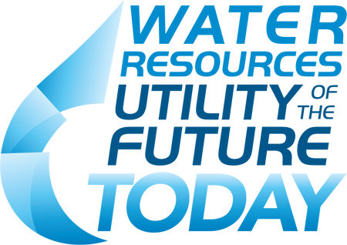

**Q: Who is eligible to apply for the recognition program?**

A: Public and private wastewater collection and/or treatment systems (water resource recovery facilities) of all sizes are encouraged to apply. Wastewater treatment plants that treat stormwater are eligible to apply, but would not be assessed only on the basis of their stormwater operations.

**Q: Is there a cost to apply for recognition?**

A: No! The Recognition Program is free of cost to participants.

**Q: When are the 2017 applications due, and where do I send the application?**

A: Applications are due by 5:00pm Eastern Time, June 9, 2017 and should be sent to [UtilityRecognition@wef.org](mailto:UtilityRecognition@wef.org).

**Q: What format is required?**

A: Applicants must fill out the application form in Microsoft Word and submit preferably as a Word document although PDF documents are also acceptable.

**Q: Can I include attachments with my application? Does the Narrative count as an attachment?**

A: Your Narrative can be submitted as a separate document from your Activity Area responses and your Certification Statement, but no other attachments, graphics, charts, photos or additional materials will not be accepted.

**Q: When will applicants be informed whether or not they were selected?**

A: All applicants will be informed by or before July 28, 2017 by email or phone.

**Q: What recognition will successful applicants receive?**

A: The Program Partners will host a ceremony at WEFTEC in Chicago, Illinois on October 3, 2017 to celebrate recognition recipients. Applicants are not required to attend WEFTEC to receive recognition. Selected utilities will receive a Utility of the Future Today flag to proudly hang/fly as well as a certificate.

**Q: If I have a multi-plant system, can I apply for only one plant?**

A: No, recognition is acknowledged on a system-wide basis. However, if a multi-plant system has just one plant that is undertaking Utility of the Future practices that can still be a basis for receiving system-wide recognition.

**Q: If my utility applied in 2016 for more than one Activity Area and was successful; how will I know which Activity Areas were recognized?**

A: The 2016 Compendium of recognitions lists all Activity Areas that were recognized for each utility. <http://www.wef.org/UtilityoftheFuture>

**Q: If my utility was successfully recognized, how long is that recognition valid?**

A: Recognition is valid for three years. To maintain recognition after the third year, the participant must re-apply and demonstrate continual improvement. This occurs by either showing performance advancements in their previously recognized Activity Areas and/or by adding one or more new Activity Areas to their application.

**Q: If my system received recognition in 2016, can we reapply for recognition in additional areas the following year, or do we have to wait the full three years to apply again?**

A: If you applied in 2016 for an Activity Area and were not recognized for it, we encourage you to reapply in 2017 or in future years. The existing (first year) Recognition Program members are grandfathered in under the new framework. Their 2016 recognition is valid for three years, as stated in the 2016 application package, but 2016 recipients are also invited to apply in 2017 if they wish to receive additional recognition in any Activity Area that they choose. 2016 recipients are not required to submit an Organizational Culture narrative if they choose to apply in 2017.

**Q: How many utilities will be selected for recognition each year?**

A: There is no set limit for the number of applicants that will be selected. It’s important to remember this is not a competition; but a recognition program. Reviewers will evaluate each application independently of all other applications.

**Q: The application states that utilities must have ‘no major violations’ to qualify for recognition. What constitutes a ‘major violation’?**

A: Applicants must have no major violations of their National Pollutant Discharge Elimination System (NPDES) permit requirements for the previous year based on the date of its application. If specific questions arise on what constitutes a major violation, applicants are encouraged to contact their state NPDES point of contact for further information. If the state has not been delegated authority to operate the NPDES program, applicants should contact their NPDES point of contact in the EPA Regional office.