The Utility of the Future Today
  - Joint Recognition Program
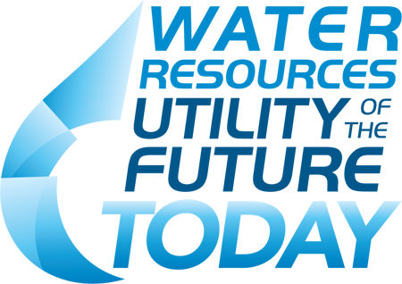

2018 APPLICATION FOR RECOGNITION

2017 DRAFT APPLICATION FOR RECOGNITION

2017 DRAFT APPLICATION FOR RECOGNITION

2017 DRAFT APPLICATION FOR RECOGNITION

2018 APPLICATION FOR RECOGNITION

2017 DRAFT APPLICATION FOR RECOGNITION

2017 DRAFT APPLICATION FOR RECOGNITION

2017 DRAFT APPLICATION FOR RECOGNITION

The “Water Resources Utility of the Future” was first articulated in a 2013 publication jointly prepared by the National Association of Clean Water Agencies (NACWA), the Water Environment Federation (WEF), and the Water Environment Research Foundation (WERF). The Water Resources Utility of the Future: A Blueprint for Action sought to capture in one place current, emergent, and possible wastewater utility opportunities that, packaged together, presented a revolutionary future for the sector. That revolution would transform the traditional wastewater treatment system to a community-based resource recovery center and leader in the overall sustainability and resilience of the communities they serve. This Recognition Program has been specifically designed to further promote and enable the emergence of this new business model for the entire water sector (reaching beyond the Blueprint’s focus on wastewater systems), provide recognition for those achieving these outcomes, and encourage peer-to-peer learning among utility members of the Recognition Program and with other utilities.
The sponsoring organizations for this recognition program understand that substantial excellence in the operations of water sector services (drinking water, wastewater, and stormwater) systems exists today. Many utilities optimize and continually improve their operations, consistently meet or exceed their regulatory requirements, plan and invest effectively for the maintenance, repair and replacement of their infrastructure, and engage their employees and communities in meaningful and productive ways.
While a variety of initiatives exist to promote and acknowledge excellent performance and sustainable management of utilities focused on our sector’s historic priorities – providing reliable, affordable, and responsible water sector services, the most prominent of these is Effective Utility Management (EUM) (www.WaterEUM.org). EUM is supported by eleven Collaborating Organizations, including all five partners of this Recognition Program. The Ten Attributes of Effectively Managed Utilities and Five Keys to Management Success form the basis for Effective Utility Management. When taken together, these Ten Attributes and Five Keys represent the basis for excellence in utility management. While EUM is not a requirement for recognition under this program, utilities are encouraged to use the EUM framework as they seek to become a Utility of the Future.
This Utility of the Future Today Recognition Program seeks to promote actions that build on this foundation of excellent management and help small, medium, and large water sector utilities transform their operations over time. The Utility of the Future Activity Areas identified in this application package focus on the key building blocks to this transformation: recovery and new uses of a full range of resources; and engagement as a leader in the full water cycle and broader social, economic, and environmental sustainability of the community. In addition, transformation of the internal utility culture in support of these innovations, and engagement in the community and formation of partnerships are necessary for success when operating outside of the traditional span of control of the utility.

Program Statement of Purpose
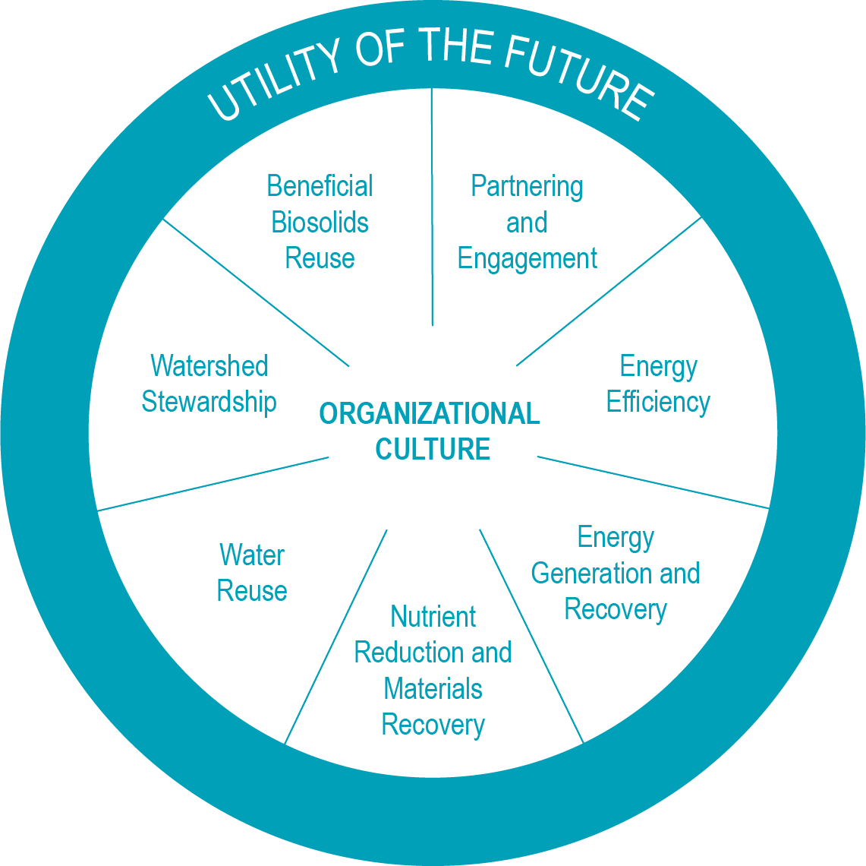
The Utility of the Future Today Recognition Program seeks to reach deeply into the water sector to form and motivate a community of like-minded water utilities engaged in advancing resource efficiency and recovery, developing proactive relationships with stakeholders, and establishing resilient, sustainable, and livable communities. The Recognition Program, through the aggregation and sharing of utility advancements and experiences, will enable participants across a broad continuum of capacities and capabilities to learn from each other and continually grow and sustain their efforts to be, and continually advance the concept of, the Utility of the Future.
The Recognition Program seeks to encourage utilities to embed the principles of the Utility of the Future within their organization, beginning with Organizational Culture. Organizational Culture is the foundation by which all other Utility of the Future Activity Areas are sustainably supported.
Utilities receiving recognition through this program are expected to share their practices and experiences to create a community of practice around the Utility of the Future Today, and to enable other utilities to continually learn from each other and evolve as a sector.

Eligible Applicants
- Public and private water sector utilities of all sizes that can demonstrate achievement of the application requirements are encouraged to apply.
- Applicants must have no major permit violations in the past year prior to the submission date of their application.

Application Requirements
To be considered for recognition, applicants must submit the following written materials. Each are described further in this information:
- Application Part 1: Background Information
- Application Part 2: Utility of the Future Today Organizational Culture Narrative
- Application Part 3: Utility of the Future Today Activity Area Description
- Application Part 4: Signed certification statement
Applicants should fill out the form in Microsoft Word and submit as a Word document to UtilityRecognition@wef.org by 5:00pm Eastern Time, May 30, 2018. Attachments, graphics, charts, photos or additional materials will not be accepted as part of an application package. Should you have questions about the application, please contact UtilityRecognition@wef.org, or refer to the 2018 FAQ document.

Basis for Recognition
Successful applicants will need to demonstrate that they are engaged in developing and growing an Organizational Culture that supports Utility of the Future implementation, as well as their selected Activity Area in a meaningful and robust manner, consistent with the principles of the Utility of the Future. Reviewers will take into consideration an applicant’s current engagement and performance, as well as projected future results.

Notification and Presentation of Recognition
Applicants will be informed whether or not they were selected for recognition by or before July 13, 2018 by email or phone. A ceremony will be held at WEFTEC in New Orleans, Louisiana on September 29 - October 3, 2018 to celebrate recognition recipients. Applicants are not required to attend WEFTEC to receive recognition. Selected utilities will receive a Utility of the Future Today flag to proudly hang/fly as well as a certificate.

Recognition Program Membership
Utility of the Future Today recognition is granted for a three-year period – this applies to both the Organizational Culture narrative and recognition, as well as the additional Activity Area. After three years, program members must renew their recognition. The applicant will need to: 1) show advancements in Organizational Culture, and 2) either show advancement in a previously recognized Activity Area or apply in a new Activity Area.
Sponsoring organizations reserve the right to withdraw recognition from any previously selected applicant at any time.

Expansion of Recognition for Program Members
In the subsequent two years after receiving recognition, program members are invited (but not required) to submit up to one additional Activity Area annually to receive further recognition during their three-year membership.
For example: a utility recognized in 2016 in Watershed Stewardship may apply for recognition in 2017 and 2018 for one additional activity area per year by submitting materials only for that activity area and omitting application information related to Organizational Culture (Application Part 2). In 2019, the utility may reapply to renew their recognition.

Application Contents
Application Part 1: Background Information 5
Application Part 2: Utility of the Future Today Organizational Culture Narrative 6
Application Part 3: Utility of the Future Today Activity Area Description 7
Utility of the Future Today Activity Areas 8
Application Part 4: Certification Statement 10
Appendix 1: Example Activities by Area 11
Appendix 2: Additional Example Performance Measures & Results by Area 15

Application Part 1: Background Information
Utility Description (combine all plants if a multi-site system)
Utility Name:

Type (e.g., single plant, regional system, multiple plants, collection or distribution system only, stormwater, etc.):

Service Area (square miles): |  | Average Annual Daily Flow or Demand (MGD):
Population Served:

Location
Street Address:

City: State: |  | Country:
Zip Code/Country Code:
Utility Representative Contact Information
Name: | Phone: |  | Email:
If this application has been prepared by another entity on behalf of the utility, provide the information of the preparer below
Name: | Title: |  | Contact Information (phone or email):
Current Program Members Only
Fill in this section only if the utility has been recognized as a Utility of the Future Today in prior years
In what year did the utility achieve recognition as a Utility of the Future Today?

In which Activity Area(s) has the utility been recognized previously? Include all Activity Areas for which the utility received recognition in 2016 and/or 2017.

__ Activity Area 1: Beneficial Biosolids Use
__ Activity Area 2: Partnering & Engagement
__ Activity Area 3: Energy Efficiency
__ Activity Area 4: Energy Generation & Recovery
__ Activity Area 5: Nutrient Reduction & Materials Recovery
__ Activity Area 6: Water Reuse
__ Activity Area 7: Watershed Stewardship (__IGP)

Application Part 2: Utility of the Future Today Organizational Culture Narrative
A Utility of the Future Organizational Culture emphasizes a collaborative workplace that inspires and embraces continual improvement and learning through a high level of employee, community, and stakeholder engagement. Every employee is empowered to creatively problem-solve, allowing innovation to be infused throughout the organization.
A Utility of the Future is a “learning organization,” where employee enrichment and job enhancement are valued and managed. An effective Utility of the Future Organizational Culture harnesses the power of employee engagement to achieve key organizational goals. A Utility of the Future recognizes its role as a leader in its community, exercises outstanding customer service, and is an effective environmental steward of the community’s natural resources.
In preparation of a new application, utilities may wish to review successful applications, as they were submitted, from the 2016 and 2017 honorees by opening the following links:
2016 Honorees Compendium
2017 Honorees Compendium
To expedite the review process, the application review panel (consisting of six utility general managers/executives) specifically identified strong "Organizational Culture" narratives from three model applications from the City of Charlotte, Fairfield Sewer District, and the West County Wastewater District.

Past Honorees and Successful Applications
Organizational Culture is the backbone of a Utility of the Future. Each applicant must submit a narrative that provides an overview of its programs and practices relative to their utility’s Organizational Culture, in support of the Utility of the Future model.
Example practices and measures relative to Organizational Culture can be found in Appendices 1 and 2.
The narrative must be a minimum of 500 words, but no more than 1500 words.

Application Part 3: Utility of the Future Today Activity Area Description
Each applicant is required to submit a description for the one Activity Area of their choosing – the seven Utility of the Future Today Activity Areas are listed and defined on the following page. The purpose of the description is to demonstrate robust engagement in that Activity Area.
Your description should be no more than 2000 words.
The description includes three main components:
- Overview Paragraph: Describe the practices/activities/programs that your utility has engaged in relative to the chosen Activity Area. For reference, a list of example practices related to each Activity Area are included in Appendix 1. This list is not meant to be comprehensive, but instead demonstrates the types of activities that could be included in the scope of each area. Please include no more than 1-2 sentences per activity that you describe in this section.
- Question & Answer: Respond to the questions listed below in as much detail as possible to provide a guide to other utilities seeking to learn from your experiences and implement similar activities/practices at their system.
  - How did you go about implementing the practices/activities/programs that you described in your Overview Paragraph?
  - What type and amount of resources were needed to support implementation? (e.g., financial, staff, other)
  - Did you partner with other stakeholders or organizations as a part of your implementation process?
  - What was the most critical obstacle that your utility had to overcome to be successful in this Activity Area, and how did you do that?
  - Has “smart” information technology supported your implementation/optimization in this area? If yes, please describe.
  - Where could other utilities go to find additional information on this Activity Area or the activities/practices/programs that you implemented?
- Performance Measures & Results: Using the table below, please describe the measures that you use to gauge performance in this Activity Area, including the targets that you set for each measure and your actual outcomes to date. For your reference, a list of example measures for each Activity Area is included in Appendix 2.
Measure  What are you measuring? | Targets  What was your goal/intended outcome? | Outcomes  What were your actual outcomes?

Utility of the Future Today Activity Areas

Activity Area 1: Beneficial Biosolids use
Wastewater-produced biosolids can be beneficially used to support: agriculture, silviculture, horticulture, fire restoration, and general landscape maintenance through land application; production of marketable products such as compost, amended topsoil, or construction products (e.g., bricks, road bed); and land reclamation as a substitute for other fill materials. This Activity Area does not include use of biosolids to produce energy or recovery of resources from biosolids.

Activity Area 2: Partnering & Engagement
Partnering is collaboration with stakeholders to enable the utility to meet its own Utility of the Future goals while also enhancing the overall environmental, economic, and social wellbeing of the stakeholders and the community at large. Partnering between utilities (peer-to-peer exchange), whether offering or seeking such opportunities to advance utility performance, including, but not exclusive to, Utility of the Future goals, falls into this activity area. Engagement is the interaction with customers and other stakeholders to provide ongoing opportunities for dialogue along with communication and education related to utility operations and the value of water and utility services. Through partnering and engagement, the utility proactively engages with stakeholders and community decision makers to promote the utility as a valued, competent, and trustworthy community asset.

Activity Area 3: Energy Efficiency
Energy Efficiency is the reduction of overall energy use by the utility. A utility is more energy efficient if it delivers more services for the same amount of energy or the same services for less energy.

Activity Area 4: Energy Generation & Recovery
Energy Generation & Recovery captures efforts to minimize the use of non-renewable energy; generate renewable (green) energy to the maximum extent practicable; and recover thermal, chemical, and hydraulic energy to the maximum extent possible. In doing so, the water Utility of the Future will not only seek to optimize its water quality performance, but also look to minimize its carbon footprint, reduce its vulnerability to climate change, and better manage energy costs and requirements.

ACTIVITY AREA 5: NUTRIENT Reduction & MATERIALS RECOVERY
Nutrient reduction in a cost effective and efficient manner is a desired outcome of many utilities. The use of creative operational protocols and innovative technologies to achieve reductions of nutrients discharged into the environment is an activity of utilities of the future of all sizes. Materials recovery is the extraction of ammonia phosphorus, nitrogen compounds, metals and other marketable commodities during the treatment process and includes lower tech activities such as recycling/reusing/repurposing paper, pallets, containers, and other materials that otherwise would be “wasted.”

Activity Area 6: Water Reuse
Water Reuse covers opportunities to use treated waters fit for beneficial purposes such as irrigation, buffering saltwater intrusion, industrial processes, toilet flushing, fire protection, surface/groundwater augmentation, and ultimately, human consumption.

Activity Area 7: Watershed Stewardship
Watersheds are the geographic areas that channel drainage into a river or stream system. They are defined by topographic boundaries and—depending on where they are located—might encompass complex natural ecosystems, highly urbanized landscapes, or elements of both. Watershed Stewardship refers to utility investments and actions to improve water flow (reduced flooding/increased local capture) and quality conditions outside of the traditional utility span of infrastructure operations and control.

It also draws on integrated growth planning to integrate wastewater infrastructure expansion, repair, and replacement with community development planning (i.e., area plans), stormwater management planning (i.e., Total Maximum Daily Load implementation plans), climate resiliency planning, and economic development planning to maximize the benefits and fully assess cost implications (i.e., triple bottom line feasibility analyses). Activities can include urban Green Stormwater Infrastructure investments, conservation easements to preserve the ecosystem functions of undeveloped lands, and stream channel restoration.

Application Part 4: Certification Statement
I, _____________________________________ [PRINT NAME], an approved representative of my organization, ___________________________________________ [ORGANIZATION NAME], certify that all data and information provided in this application package is accurate to the best of my organization’s knowledge and has not been falsified. I certify that my organization is in good standing and has had no major permit violations in the 12 months prior to the date of submission of this application package.
_____________________________________ [UTILITY REPRESENATIVE SIGNATURE]
_________________________ [DATE]

If this application has been prepared by another entity on behalf of the utility, preparer sign below:
_____________________________________ [PREPARER SIGNATURE]
_________________________ [DATE]

Appendix 1: Example Activities by Area

Organizational Culture
- Leadership proactively engaged in both internal organizational and broader external community priorities
- Business focus that delivers best outcomes in service to community values and needs
- Participatory, collaborative culture established, dedicated to continual learning, improvement, and innovation
- Workforce and leadership development program (that includes leadership and management skills training in support of formal and informal leadership opportunities) in place to assure recruitment, retention, and continuous competency of utility staff in support of business mission and community expectations
- Provides formal or informal mentoring for young (and seasoned) professionals to attract and retain top talent through commitment to their professional development and a supportive, encouraging culture.
- Shares work experiences (including utility "peer-to-peer" partnering), ensures internal understanding and greater support for the utility’s key strategy relative to the Utility of the Future business model
- Establishes "peer-to-peer" relationships and actively partners with other utilities to offer and/or seek opportunities to advance the Utility of the Future goals broadly across the water sector
- Job enhancement and enrichment opportunities are available through a variety of standard and innovative job scope broadening techniques, that support a strong business succession and overall integration of organizational spirit
- Problem solving is encouraged at all levels, and proposed solutions are adequately funded and supported for successful implementation
- Uses an integrated and well-coordinated senior leadership team
- Employs integrated organizational communications systems
- Opportunities provided for employees to find and fix inefficiencies, and share ideas for solutions to problems
- Awareness and commitment to workplace safety established as a key organizational expectation
- Victories for organization celebrated and recognized
- Process established for periodic tracking of progress toward meeting goals and milestones around organizational Utility of the Future successes
- Mentoring program or other informal engagement with other utilities to promote Utility of the Future practices established as an organizational practice
- Staff is recognized and rewarded for suggesting improvements that save time, money, resources and/or improve outcomes
- Organization adopts Core Values aligned with community needs and desires
- Effective Utility Management-based continuous improvement program in place

Activity Area 1: Beneficial Biosolids Reuse
- Board/executive management policy established to advocate for beneficial biosolids use
- Business case evaluation conducted for beneficial biosolids use program
- Marketing plan for biosolids products created
- Participation in or certification in National Biosolids Partnership or International Standards Organization (ISO) programs
- Public engagement and education activities conducted, related to acceptance and support of beneficial biosolids use
- Alternative uses for biosolids explored and evaluated regularly
- Risk management strategies established to address threats to sustainability of beneficial biosolids use practice
- Adequate staffing secured (internally or by contract) to support biosolids programs
- Procedures established to reduce generation of biosolids in treatment systems

Activity Area 2: Partnering & Engagement
- Partnerships in place with one or more community organizations with the partnership clearly branded and working toward specifically meeting articulated objectives (e.g., a formalized partnership among community transportation, parks, and land use organizations for the incorporation of green infrastructure to reduce flooding and overflows)
- Utility is engaged in peer learning partnerships, utility “twinning” arrangements, or other informal partnerships within the utility community
- Utility seeks out assistance from or offers assistance to other utilities in formal or informal partnerships
- Neighborhood group/community project participation to create recreational opportunities and enhance community assets (e.g., parks, public spaces)
- Triple Bottom Line approach and stakeholder engagement processes used in support of decision making
- Regular meetings hosted with community stakeholders
- Environmental education opportunities offered to community (e.g., river walks, clean-ups)
- Web presence established with social media engagement
- Outreach conducted to target stakeholders and other community groups (e.g., regulators, local officials, watershed groups)
- Community workforce development programs in place
- The value of water and wastewater and stormwater collection and treatment’s role in the social, economic, public, and environmental health of the community are actively promoted by the utility and its partners within the community
- Utility positioned as a “good neighbor” and an “anchor institution” – a critical asset to its community

Activity Area 3: Energy Efficiency
- Internal policies established indicating the commitment of utility management to energy efficiency (e.g., energy efficiency standard operating procedures; board/executive management energy efficiency policy, including quantitative goals developed and shared with stakeholders)
- Energy audit/benchmarking conducted to identify priorities for energy efficiency improvements
- Individuals empowered within the utility to champion energy efficiency activities (e.g., an “energy advocate” or “energy champion”)
- Energy management-related training provided to plant staff
- Energy conserving operational methods utilized (e.g., optimization of primary sedimentation to reduce utilization of pure oxygen)
- Employee performance plans include energy program-related activities to support the utility’s energy vision and goals
- Energy efficiency master plan and communications strategy included as part of utility’s overall strategic plan
- Energy efficiency team established and empowered to implement master plan and communicate results to management and staff
- Internal incentives in place for achieving energy efficiency goals
- Energy efficiency evaluated for all equipment purchases and capital projects
- Energy performance contracts or other similar mechanisms evaluated and in place, where appropriate
- Internal energy efficiency research conducted, or participation in external research initiatives
- Sub-metering conducted for critical process units
- Participation in voluntary energy efficiency programs (e.g., EnergyStar)
- Energy conserving equipment utilized wherever possible (e.g., peak shaving equipment to reduce usage)

Activity Area 4: Energy Generation & Recovery
- Internal policy/policies established indicating the commitment of utility management to energy generation and recovery (e.g., standard operating procedures; board/executive management renewable energy conversion policy, including quantitative goals developed and shared with stakeholders)
- Internal energy sources evaluated (e.g., biogas, hydropower, heat in wastewater), and/or renewable energy sources evaluated on an ongoing basis (e.g., solar, wind, co-digestion)
- Digester gas recovered in a combined heat and power (CHP) system, and boilers in place (for process and building heating)
- Digester biogas converted to electricity and heat, and/or transportation fuel
- Solar panels, wind turbines, heat recovery, in-conduit hydro, and/or hydroelectric power generation systems installed
- Co-generation systems utilized
- Fats, oils, grease (FOG) receiving stations created

Activity Area 5: Nutrient Reduction & Materials Recovery
- Materials recovery strategy established and communicated with utility employees
- Adequate staffing secured to support materials recovery program (contractual or in-house)
- Market assessment conducted for recovered materials
- Contracts or agreements in place for materials provision
- Materials recovery opportunities explored and evaluated on a regular basis
- Alkalinity recovered during nitrogen removal processes
- Phosphorus recovered for beneficial reuse
- Unique operational protocols utilizing pre-existing infrastructure to reduce nutrients to, or beyond, the regulatory requirement
- Chemical use reduced through improved biological uptake
- Engaged with external partner(s) on new technology and support to nutrient recovery/sale
- Third party investments pursued and secured for capital costs and operating/maintenance of nutrient recovery equipment
- Revenue generated from sales of nutrients and/or other recoverable materials
- Closed loop systems created to enhance nutrient and energy recovery
- Sales enhanced through advertising for nutrients recovered
- Ability to store recovered nutrients and materials in anticipation of improved market value
- Goals for nutrient recovery established based on total nutrients available, costs, and value

Activity Area 6: Water Reuse
- Board/executive management reuse strategy established
- Communications and outreach plan developed and implemented
- Market assessments of reused water to public/private and public/public entities conducted on an ongoing basis
- Investments made in reuse infrastructure
- Building code changes made to enable reuse (e.g., reuse water code)
- Water reused for on-site irrigation or process water (e.g., vacuum pumps, seal waters, cooling towers, etc.)
- Water reused for off-site industry purposes (e.g., power generation/cooling and golf course irrigation)
- Programs developed to reduce risk of reuse and improve guaranteed reuse water quality
- Reuse water injected for salt water/groundwater control
- Indirect potable reuse (IPR) implemented for downstream water supplies
- Communication plan created to explain IPR and/or direct potable reuse (DPR) to stakeholders
- Internal plant methods established to ensure treated water quality is fit-for-purpose reuse

Activity Area 7: Watershed Stewardship
- Unified vision statement established that integrates water supply, water conservation, water recycling, runoff management, wastewater facilities planning, and infrastructure planning using a regional watershed approach
- Green infrastructure deployed to enhance infiltration, evapotranspiration, treatment, or capture and reuse of stormwater
- Watershed permitting strategy created for multiple facilities (e.g., active nutrient water quality trading under a watershed-based permit)
- Ecosystem enhancements for improved hydraulics or water quality, including:
- Riparian reforestation to enhance pollution mitigation functions
- Stream channel restoration for increased hydrologic stability
- Critical land acquisitions (e.g., conservation easements, buffer-zone purchases)
- Climate impact resilience principles incorporated into planning for new, repair, and replacement of infrastructure
- Holistic, integrated protection approach implemented to manage significant potential sources of contaminants in the watershed that improves surface water quality and avoids transferring pollutants from one resource to another
- Integrated program created to address wet weather issues, including such sources as regulated stormwater, unregulated runoff (nonpoint sources), CSOs, SSOs, peak flow at POTWs, and source water protection
- Building codes modified to allow green infrastructure
- Workforce capable of evaluating and maintaining effective green infrastructure
- Evaluation of water quality trading options
- Integration of wastewater services with urban planning entities
- Feasibility study conducted to assess the benefits and costs of green infrastructure
- Participation in voluntary programs such as the Alliance for Water Stewardship

Appendix 2: Additional Example Performance Measures & Results by Area

Organizational Culture
- Number of training sessions, % of individuals trained, and type of leadership/workforce development activities conducted (e.g., safety training)
- Internal Leadership and Supervisory Training programs in place
- Apprenticeship programs in place
- Mentoring program in place
- Level of employee engagement in the goals and vision of the Utility of the Future business model
- Active Wellness Program supported by organization
- Number of open positions that internal candidates can qualify for, as a result of employee training and enrichment programs
- Resource efficiency improvements related to staff utilization
- Employee job satisfaction (percent based on a comprehensive employee survey)
- Continuous improvement in Employee Engagement (via Employee Engagement Surveys)
- Percent of vacancies filled through the promotion of in-house candidates
- Peer-to-peer utility partnering program in place

Activity Area 1: Beneficial Biosolids Use
- Percent of biosolids beneficially used vs. total volume produced on an annual basis
- Quantification of natural resources conserved through substitution (e.g., pounds of phosphorus or other fertilizers substituted for by biosolids)
- Demonstrated performance against projected performance in business case (e.g., actual versus projected biosolids volume acquired for soil amendment by agricultural producers)
- Tons of carbon sequestered in the soil via land application of Class A and/or Class B biosolids
- Impact on customer rates
- Increase in agricultural land application
- Increase in silviculture land application
- Increase in agricultural or silviculture growth yields
- Increase in improved soil characteristics resulting from biosolids amended soils
- Amount of biosolids use for landscaping for green infrastructure projects
- Amount of biosolids use for recreational fields, golf courses, and domestic use

Activity Area 2: Partnering & Engagement
- Number and type of specific projects completed (e.g., rain gardens installed, innovative technologies, or other innovative practices adopted) associated with a partnership
- Number and type of formal recognitions of partnerships by outside groups (e.g., state or national award) and any associated results for the community (e.g., acres of green space added in the community)
- Performance improvements resulting from a partnership (e.g., reduced volume of flooding or reduced greenhouse gas emissions)
- Number of ongoing communications network actions/activities (e.g., website hits, newsletters, social media activity)
- Type and number of working agreements and collaborative initiatives for growth planning between and across different levels of government
- Type and number of changes in operating practices of other partners (e.g., nonpoint source controls by agricultural producers, food producers, consumers)
- Level of community support for the benefits and costs of becoming a Utility of the Future (e.g., annual survey results regarding community support for utility priorities)
- Support from and amount of contracting with local businesses
- Level of stakeholder involvement in decisions that affect them
- Number of outreach events conducted to publicize and build support for water and wastewater services
- Type and number of collaborations on data collection and assessment
- Amount and effectiveness of public outreach as an integral part of project planning
- Number of active utility-to-utility partnerships (can be providing or receiving services/training/resources, etc., from another utility)

Activity Area 3: Energy Efficiency
- KWh reductions in site energy use/intensity – to date or anticipated in the future (e.g., change in energy required per million gallons treated, or change in energy required per hour of pump operation)
- Translation of energy use/intensity reductions to greenhouse gas emission reductions – to date and anticipated in the future
- Current and anticipated investment (in USD) in energy efficiency projects or activities, and anticipated savings (in USD)
- USD value of other re-investments made as a result of the savings from reduced energy costs
- Percent of annual budget allocated to implementing priority energy efficiency improvements identified in energy audit

Activity Area 4: Energy Generation & Recovery
- Reduced non-renewable energy use and carbon footprint (e.g., percent of non-renewable energy use reduction, percent of greenhouse gas emissions reduction)
- Reduced reliance on the power grid (e.g., percent reduction of energy utilization coming from the grid), and corresponding reduced vulnerability to climate change and energy price fluctuations
- Cost savings (e.g., return on investment proceeds and/or avoided energy costs)
- Percent increase in renewable energy production (e.g., solar generation) or utilization (e.g., purchase of renewable energy through the grid)
- Amount of carbon sequestered
- Amount of transmission losses eliminated when providing outside power to the facilities
- Increase in use of renewable energy sources, including Renewable Energy Credit generation, and/or percent of energy use that is renewable
- Percent of total plant power demand that is generated on-site from renewable sources

Activity Area 5: Nutrient Reduction & Materials Recovery
- Type and percent of materials recovered vs. materials available
- Revenue generated and/or costs avoided from materials recovery and marketing activities
- Demonstrated performance as projected in market assessment
- Number of external and/or public-private partnerships for recovered material sales
- Cost avoided through use of advanced technology to achieve nutrient reductions (e.g., capital cost avoided through more efficient use of existing infrastructure)

Activity Area 6: Water Reuse
- Water beneficially reused
  - Percent change of static water levels or reservoir due to new actions (augmentation)
  - Ratio of reuse quantity vs. wastewater volume processed (normalized change)
- Environmental benefits
  - Amount of movement or reduction of saltwater front (in feet)
  - Amount of decreased diversion of freshwater from sensitive ecosystems
  - Area irrigated solely by recycled water
- Local supply
  - Reduced dependence on purchased water and energy used to treat purchased water
  - Climate-independent water supply of reuse water
- Costs for, or sales of, treated water fit-for-purpose reuse
- Level of public acceptance of reuse commitments for non-potable opportunities
- Use of advanced treatment (ultrafilters (UF), reverse osmosis (RO), granular activated carbon (GAC)
- Type and use of enhanced disinfection of reuse water besides chlorine residual, such as UV light

Activity Area 7: Watershed Stewardship
- Reduction in wet weather impacts (e.g., flooding, CSOs, SSOs, gallons of infiltrated water not reaching collection systems)
- Reduced unit costs for water quality improvements (e.g., financial benefits of a water quality trade)
- Enhanced pollution mitigation (e.g., sediment capture through green stormwater infrastructure)
- Increased hydrologic stability (e.g., reduction in flood-prone land area)
- Reductions (e.g., VSAT Risk Reduction Units change) in vulnerability to climate change
- Created or enhanced wetlands and riparian habitats (e.g., number of projects, or acres covered)
- Rate payer savings resulting from planning and projects between transportation and other public utilities

The Utility of the Future Today
  - Joint Recognition Program

The Utility of the Future Today
  - Joint Recognition Program

Previously titled “Community Partnership and Engagement” and updated in the 2018 Program.
Previously titled “Nutrient and Materials Recovery” and updated in the 2018 Program.
2016 Activity Area “Integrated Growth Planning” was removed from the 2017 Program and is encompassed in Activity Area 7. If the utility was recognized in this 2016 Activity Area, please check the box for AA7 and the box for IGP.

