Tool No. 5

Start an InFLOW Program

InFLOW was launched to identify promising students and young professionals from underrepresented groups who are interested in careers in the water industry. This initiative continues to identify and introduce students and young professionals to careers in the water industry. Building off the successes and the lessons learned from previous years, the MA is continuing in its mission to change the face of the water industry and help build a more diverse and inclusive world. One MA is starting a mentorship/partnership to develop a relationship between conference attendee and experienced professional beginning before the conference.

Water Environment Federation
House of Delegates
DE&I Work Group (2021)
Starter Kit Subgroup
DRAFT WEF InFLOW writeup
KL 5/23/2021
PVC 7/26/2021

WEF InFLOW Program
https://www.wef.org/inflow
WEF initiated the InFLOW program to enhance diversity and inclusion in the water workforce. InFLOW stands for Introducing Future Leaders to Opportunities in Water.
InFLOW is a scholarship opportunity that engages participants in WEF programs and events with the goal to solidify their interest in working in the water sector and increasing the probabilities for employment and long-term success in the sector.
There are two potential paths:
“STEMpath identifies scholars enrolled in undergraduate or graduate degree programs from historically underrepresented ethnic and racial groups.”
“CareerTech partners with community based organizations to expose scholars in job readiness programs to the variety of rewarding career possibilities in water quality.”

WEF encourages its Member Associations to develop their own InFLOW programs. A number of MAs have already expressed interest and taken steps to implement their own program. For example, Illinois WEA brought WEF InFLOW to its annual conference in 2019. Other MA’s exploring WEF InFLOW include:
- Pacific Northwest Clean Water Association
- WEA of Texas
- New England WEA
- North Carolina WEA, and
- Virginia WEA

First Steps …
- MAs interested in this program should get connected with those at WEF who can provide insights and advice. visit www.wef.org/inflow and email inflow@wef.org.
- Obtain support from the Board of Directors, including identification of a champion for the initiative.
- A committee or subcommittee of interested and supportive members will be needed. Get advice from WEF and other MA’s on the formation of committees to lead implementation of WEF InFLOW programs at the MA level.
- Promote the initiative and seek volunteers and support. This is a great opportunity for sponsorships.

Insights for a successful program from the Illinois WEA experience
- Approval - obtain approval from the Conference Planning Committee
- Budget planning (Exhibit A)
  - Number of students
  - Hotel accommodation
  - Meals
  - Transportation
  - Sponsorships
- Candidates searching
  - School identification (focus on under-represented schools; minority societies of “big” schools; consider access to conference center)
  - Contacts (YP can help with current school-tie)
  - MA’s communication channels (E-blast; quarterly newsletter)
  - Express-of-interest Form (Exhibit B)
- InFLOW program/itinerary
  - Sample program (Exhibit C)
  - Seating arrangements (in Banquet)
  - Session attendance requirements
- Pre-conference
  - Pre-conference calls with candidates to answer any questions they may have
- Conference
  - Conference Committee/volunteers to “chaperone” or constantly checking in with candidates throughout the conference
  - Active participation anticipated
  - Networking (candidates and potential employers)
  - Goal: Introduce different opportunities water and wastewater industry has to offer
- Post-conference
  - Survey (Exhibit D)
  - Follow-up with candidates
  - InFLOW committee wrap-up meeting (Lessons learned)

Additional information can be found at:
https://www.wef.org/resources/wef-inflow-program/wef-inflow-program/
https://www.wef.org/globalassets/assets-wef/3---resources/inflow/inflow-brochure-2021_2.11.21---final.pdf
https://www.pncwa.org/index.php?option=com_content&view=article&id=672:inflow-program&catid=38:main-newcms&Itemid=464
https://www.pncwa.org/index.php?option=com_content&view=article&id=664:inflow-subcommittee&catid=41:committee-member-services&Itemid=456
https://www.pncwa.org/index.php?option=com_content&view=article&id=579:Sponsorships&catid=46:committee-marketing-sponsorship&Itemid=468

Exhibit A
Example InFLOW Budget

Insert Exhibit A document here

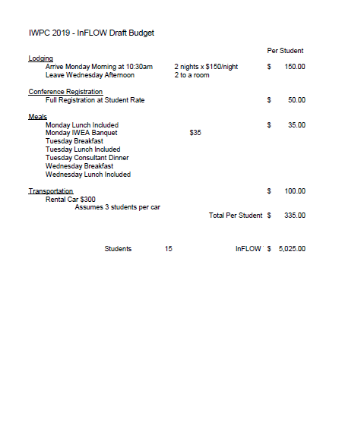

Exhibit B

Example InFLOW Letter

Insert Exhibit B document here

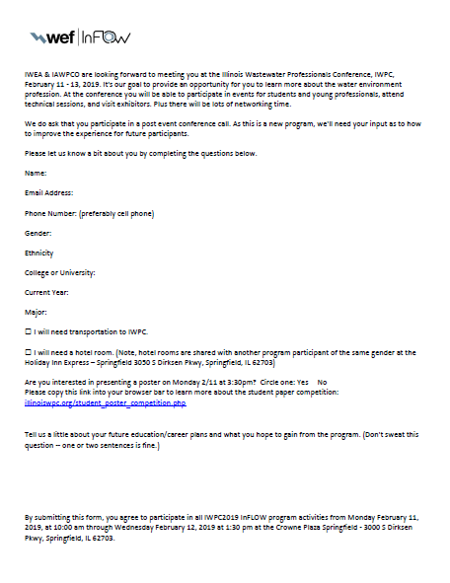

Exhibit C

Example InFLOW Program

Insert Exhibit C document here

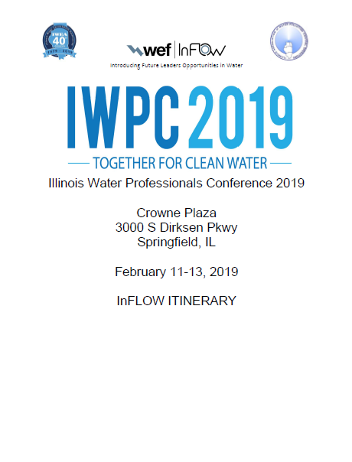

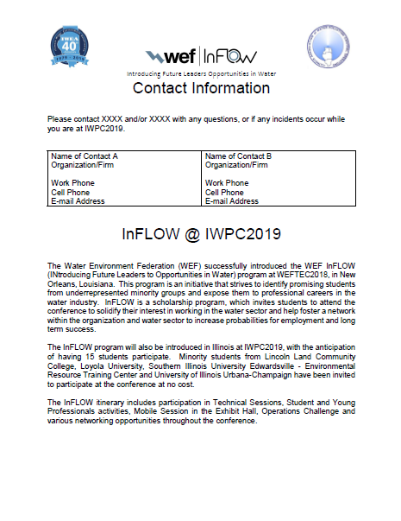

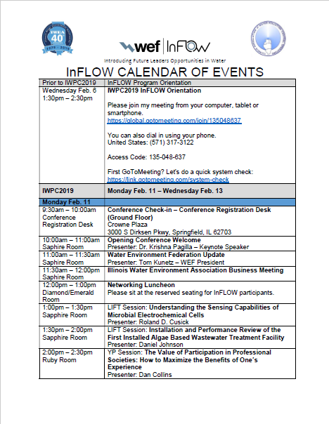

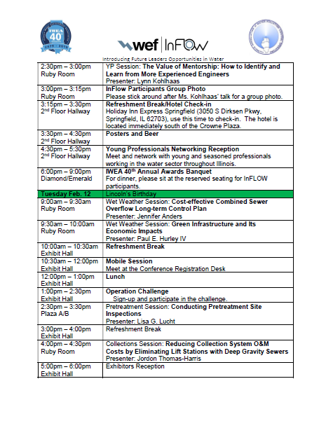

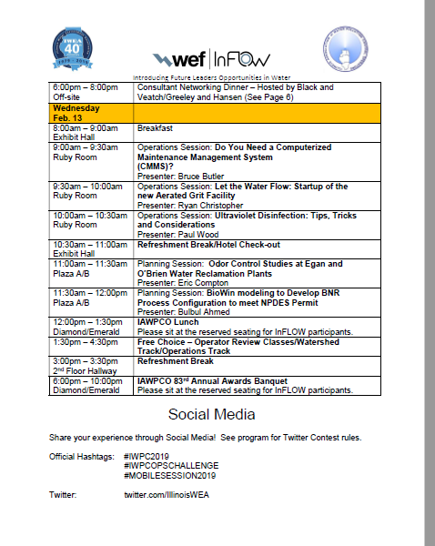

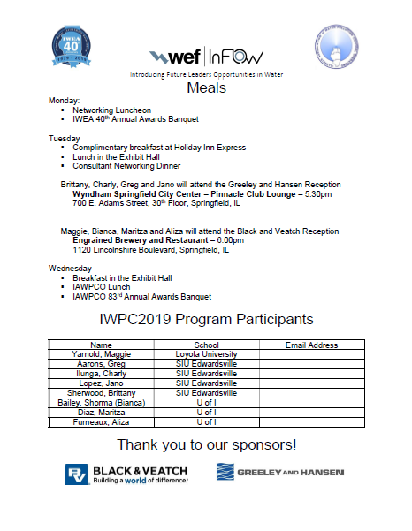

Exhibit D

Example Post InFLOW Event Survey

Insert Exhibit D document here

