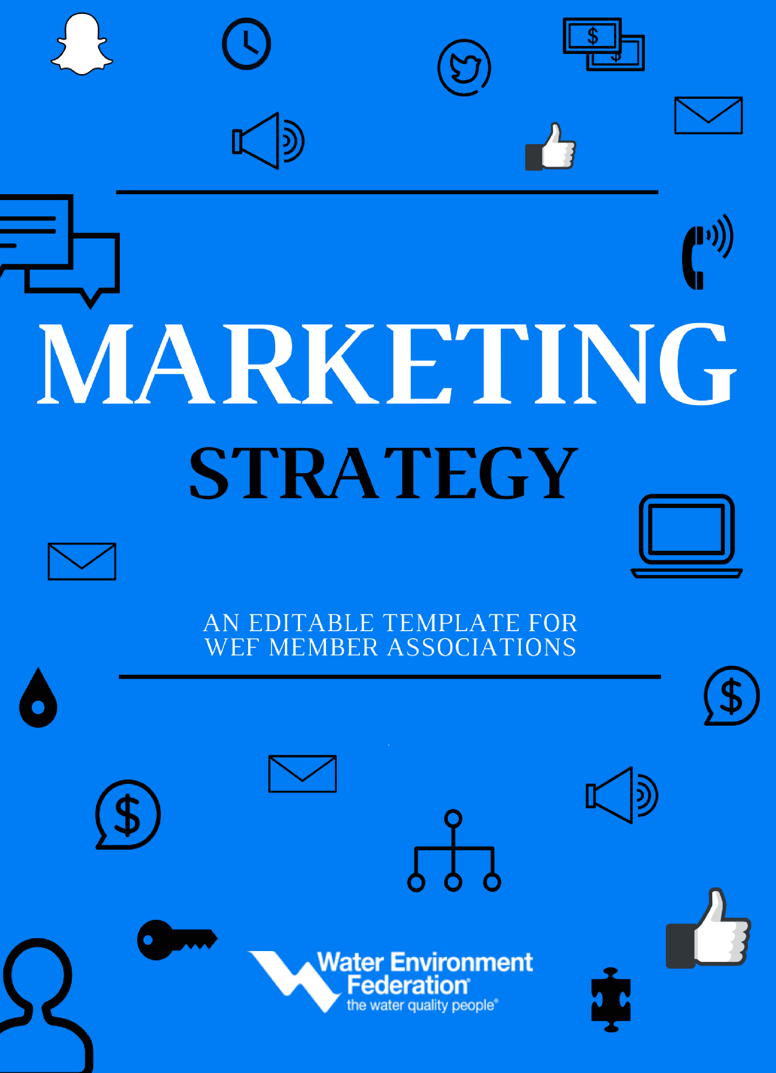
What is a Marketing Plan?
A marketing plan is a comprehensive document or blueprint that outlines your member association’s advertising, communications, and marketing efforts for the coming year. It describes business activities involved in accomplishing specific marketing objectives within a set period. In this resource, we’ve broken the planning process into six steps: Identify Objectives, Conduct Market Research, Identify Target Market, Building Strategy, Define Budget, Analyze Results

MARKETING OBJECTIVE
Your Marketing Objective sets the tone for your overall marketing plan. This is where you outline the goals you hope to accomplish. Setting realistic, yet challenging goals can sometimes be challenging. Gather a group of internal stakeholders to help drill-down and identify 1-3 primary marketing goals for your member association.
How to Use This Form: Click text below to edit
Instructions: This information will be derived from your organization’s business plan. Reviewing the business plan will give you a better understanding of financial goals and benchmarks that need to be reached in the upcoming year. As you outline each objective think about your strengths, weaknesses, opportunities, and threats (SWOT) as it pertains to each. This will help you to recognize areas in which you excel and areas in which you may need additional help to meet your objectives.

- OBJECTIVE 1: Enter Here (Example – To increase membership growth by 5%)
Click or tap here to enter text.

- OBJECTIVE 2: Enter Here (Example – Increase social media engagement and tracking)
Click or tap here to enter text.

- IDENTIFY TRENDS: Enter Here (Example – Increase event registration by 10%)
Click or tap here to enter text.

MARKET RESEARCH
Understanding your industry is an essential component to developing a marketing plan. Within this section your will outline key elements about the buying habits of your audience, your overall market size, market growth or decline, and any current trends.

How to Use This Form: Click text below to edit
Instructions: This information will be derived from your internal data sources, such as your member database, event registration records and sales records for your MA. Write 1-3 paragraphs for each.

- IDENTIFY YOUR MARKET: Questions to Consider (What types of businesses do you service? How many company’s or organization exist within field of service? How many members do you have? What is the potential for increasing your membership? Who are your competitors?)
Click or tap here to enter text.

- OUTLINE MEMBER BUYING HABITS: Questions to Consider (What products do you offer? Which events or products do your members like most/least?)
Click or tap here to enter text.

- IDENTIFY TRENDS: Questions to Consider (What’s happening in your field? What’s new, what’s innovative and what’s time tested?
Click or tap here to enter text.

IDENTIFYING YOUR TARGET MARKET
A well-designed target market description identifies your most likely buyers. This will help you to build member/buyer personas for each segment of your membership.

How to Use This Form: Click text below to edit. Copy and paste the segment block as needed to complete all segments.
Instructions: Write a brief description of each member segment you service. Include demographic information such as average age of segment, gender, income, geographic location, and education. This information will be derived from information collected from your membership on applications, registrations, surveys, or in-person focus groups. This information should reside within your customer records database.

SEGMENT 1: INSERT NAME (EXAMPLE: PROFESSIONALS)
Description: Click or tap here to enter text.

Job Titles: Enter possible job titles for members within this segment | Click or tap here to enter text.
Salary Range: Outline the average salary range for the types of positions listed within this segment | Click or tap here to enter text.
Education: What level of education does this segment have? | Click or tap here to enter text.
Location: Where do members in this segment live? | Click or tap here to enter text.
Gender: How many male or female members are in this segment? | Click or tap here to enter text.
Age: What is the average age of members within this segment | Click or tap here to enter text.
Goals: What are the goals of this segment? | Click or tap here to enter text.

SEGMENT 2: INSERT NAME (EXAMPLE: OPERATORS)
Description: Click or tap here to enter text.

Job Titles: Enter possible job titles for members within this segment | Click or tap here to enter text.
Salary Range: Outline the average salary range for the types of positions listed within this segment | Click or tap here to enter text.
Education: What level of education does this segment have? | Click or tap here to enter text.
Location: Where do members in this segment live? | Click or tap here to enter text.
Gender: How many male or female members are in this segment? | Click or tap here to enter text.
Age: What is the average age of members within this segment | Click or tap here to enter text.
Goals: What are the goals of this segment? | Click or tap here to enter text.

SEGMENT 3: INSERT NAME (EXAMPLE: STUDENTS)
Description: Click or tap here to enter text.

Job Titles: Enter possible job titles for members within this segment | Click or tap here to enter text.
Salary Range: Outline the average salary range for the types of positions listed within this segment | Click or tap here to enter text.
Education: What level of education does this segment have? | Click or tap here to enter text.
Location: Where do members in this segment live? | Click or tap here to enter text.
Gender: How many male or female members are in this segment? | Click or tap here to enter text.
Age: What is the average age of members within this segment | Click or tap here to enter text.
Goals: What are the goals of this segment? | Click or tap here to enter text.

MARKETING STRATEGY
Your marketing strategy is your path to sales goals. It outlines the steps you will put in place to attract members and increase sales. Your marketing strategy will break-down specific tactics including events, direct mail, email, social media, content strategy, webcasts, and partnerships that will help you gain members.

How to Use This Form: Click on text below to edit.
Instructions: In this section, you will outline a marketing strategy to support each Marketing objective you’ve outlined in your plan. Your marketing strategy should include a robust marketing channel mix including social media, digital advertising, direct-mail, and print media. Once you have developed a marketing strategy and supporting tactics for each objective. You can plan a more specific marketing calendar that will list important dates for workflow, deadline, and asset distribution.
Objective 1: Enter Here – (SAMPLE: To Increase membership growth by 5%)
Campaign 1 | Marketing Mix | Time-Frame
Implement a content marketing strategy to bring in new leads | Social Media, Paid Advertising, Email Marketing | Completed by March 31
Tactic 1: Survey membership to learn the types of content they are most interested in
Tactic 2: Develop content for each member segment
Tactic 3: Distribute content via outlined mix of marketing channels
Tactic 4: Track new leads and report outcomes
Campaign 2 | Marketing Mix | Time-Frame
Click or tap here to enter text. | Click or tap here to enter text. | Click or tap here to enter text.
Tactic 1: Click or tap here to enter text.
Tactic 2: Click or tap here to enter text.
Tactic 3: Click or tap here to enter text.
Tactic 4: Click or tap here to enter text.

Objective 2: Click or tap her to enter text
Campaign 1 | Marketing Mix | Time-Frame
Click or tap to enter text | Click or tap to enter text | Click or tap to enter text
Tactic 1: Click or tap to enter text
Tactic 2: Click or tap to enter text
Tactic 3: Click or tap to enter text
Tactic 4: Click or tap to enter text
Campaign 2 | Marketing Mix | Time-Frame
Click or tap here to enter text. | Click or tap here to enter text. | Click or tap here to enter text.
Tactic 1: Click or tap here to enter text.
Tactic 2: Click or tap here to enter text.
Tactic 3: Click or tap here to enter text.
Tactic 4: Click or tap here to enter text.

Objective 3: Click or tap her to enter text
Campaign 1 | Marketing Mix | Time-Frame
Click or tap to enter text | Click or tap to enter text | Click or tap to enter text
Tactic 1: Click or tap to enter text
Tactic 2: Click or tap to enter text
Tactic 3: Click or tap to enter text
Tactic 4: Click or tap to enter text
Campaign 2 | Marketing Mix | Time-Frame
Click or tap here to enter text. | Click or tap here to enter text. | Click or tap here to enter text.
Tactic 1: Click or tap here to enter text.
Tactic 2: Click or tap here to enter text.
Tactic 3: Click or tap here to enter text.
Tactic 4: Click or tap here to enter text.

BUDGET
Develop an annual and monthly marketing spending plan. You’ll want to check your actual expenses again each budget monthly to ensure that you’re on target for the year.
How to Use This Form: Click on text below to edit.
Instructions: In this section, map out you annual marketing budget. This will help you to create a secondary monthly spending plan. You’ll need to include all categories that you intend to have marketing expenses for the year.
Budget Category | Account Number | Budgeted for ENTER YEAR | Actuals for ENTER YEAR
SAMPLE: Electronic Promotions | SAMPLE: 1234-5678-17
- Email Marketing | Click or tap here to enter text. | $ 1,000
- Social Media | Click or tap here to enter text. | $ 2,000
- Paid Advertising | Click or tap here to enter text. | $ 5,000
SAMPLE: Publications | Click or tap here to enter text.
- Click or tap here to enter text. | Click or tap here to enter text. | $ Click or tap here to enter text.
- Click or tap here to enter text. | Click or tap here to enter text. | $ Click or tap here to enter text.
- Click or tap here to enter text. | Click or tap here to enter text. | $ Click or tap here to enter text.
SAMPLE: WEBSITE | Click or tap here to enter text.
- Click or tap here to enter text. | Click or tap here to enter text. | $ Click or tap here to enter text.
- Click or tap here to enter text. | Click or tap here to enter text. | $ Click or tap here to enter text.
- Click or tap here to enter text. | Click or tap here to enter text. | $ Click or tap here to enter text.
 | TOTAL | $ 8,000

ANALYZE PLAN SUCCESS
At the end of each fiscal year you’ll want to analyze the success and failures of your marketing plan, however you’ll want to implement a strategy that allow you to measure effectiveness along the way.
How to Use This Form: Click on text below to edit.
Instructions: In this section, you will identify your Key Performance Indicators (KPIs). Use this form to track your marketing activities. Use Google Analytics and the metrics dash boards available in most social media platforms to chart your success and determine ROI (Return on Investment).
Campaign Description:
Click or tap here to enter text.

KPI 1: How did our members respond to our Email Marketing Efforts?

Email Sent | Email Opens | Email Clicks | Conversions | Cost of Email
Click or tap here to enter text. | Click or tap here to enter text. | Click or tap here to enter text. | Click or tap here to enter text. | Click or tap here to enter text.
KPI 2: How did our members respond to our Social Media Efforts?

Post Clicks | Post Impressions | Cost Per Click (CPC) | Cost Per Impression (CPM) | Engagement (Likes)
Click or tap here to enter text. | Click or tap here to enter text. | Click or tap here to enter text. | Click or tap here to enter text. | Click or tap here to enter text.
KPI 3: How did our members respond to our Print Marketing Efforts?

Quantity Printed | Quantity Mailed | Cost Per Piece | Responses
Click or tap here to enter text. | Click or tap here to enter text. | Click or tap here to enter text. | Click or tap here to enter text.

