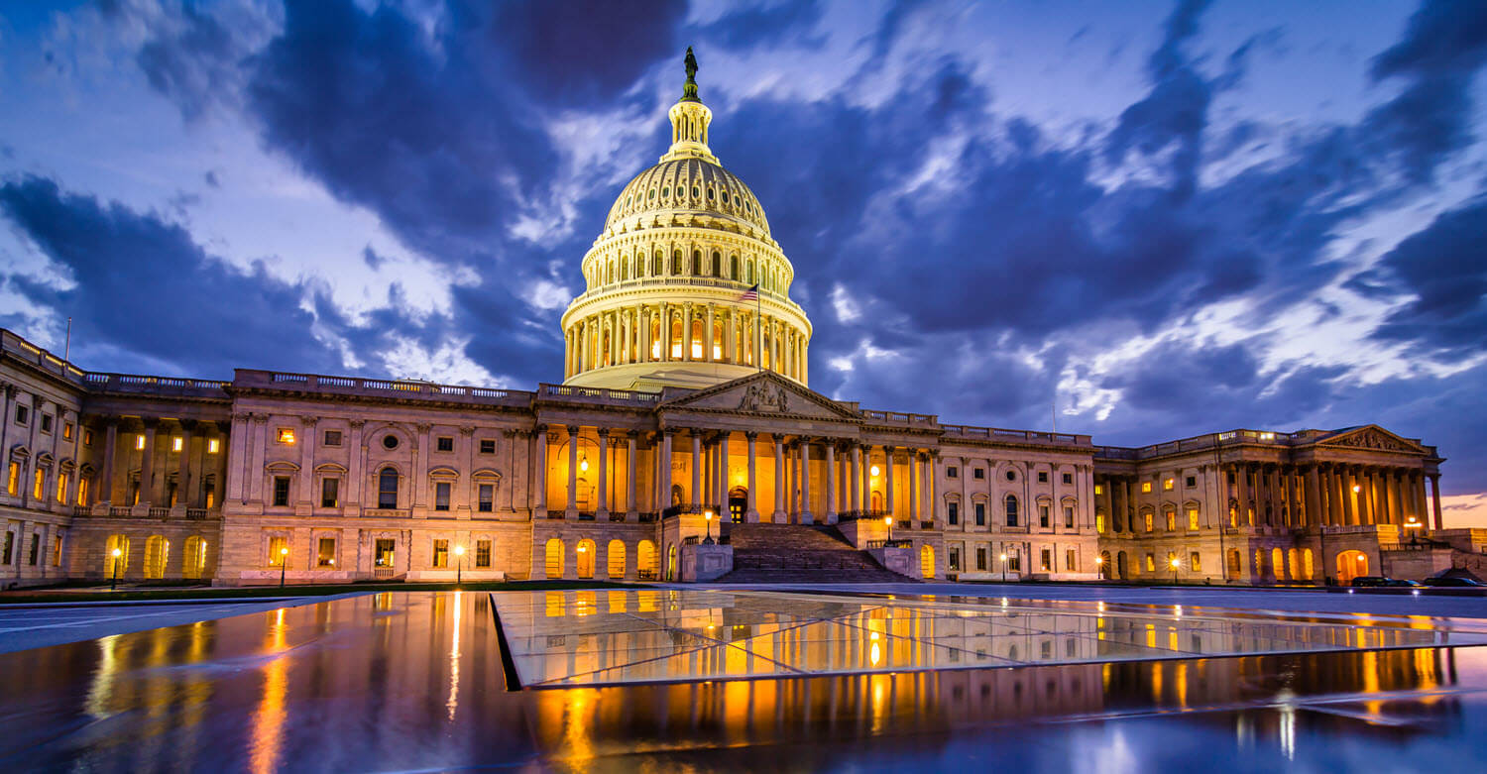
ENLIGHTEN
ENGAGE
EDUCATE
BE A WATER ADVOCATE!
WEF members are the experts when it comes to water issues.
We need to speak up and share our knowledge with those who are making decisions on funding and regulations. Aging infrastructure, new and updated regulations, resiliency issues, coupled with economic pressures are placing unprecedented stress on local governments and agencies that provide essential water services. With reduced revenues, elected officials are being called upon to make tough choices that will impact water quality and the viability of our communities for generations to come.
As water professionals, we can create a better path—a path that leads to public appreciation for the value of water, investment in our essential water infrastructure, and a better quality of life for our states and communities. WEF’s Water Advocates Program is a simple and effective way for you to become more involved with engaging elected officials, the public, and other interested stakeholders on important water issues. The Water Advocates Program provides training and engagement to promote grassroots advocacy before elected officials, the public, and other stakeholders with the goal of creating a network of trained water advocates not only in every MA, but also in every state and U.S. Territories.
Visit the Water Advocates website at https://www.wef.org/advocacy/water-advocates/ and let your voice be heard, or email Amy Kathman at WEF to join the Water Advocates program: akathman@wef.org
Include your name, title, organization, address, e-mail, and telephone number. After you sign up, you will be in the Water Advocates program and receive important announcements about actions you can take to help.

