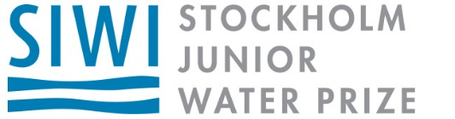

Thank you for your interest in water science!

The [Your Member Association’s Name] has been pleased to review your project and finds that it meets the criteria to enter the [Your State] state Stockholm Junior Water Prize (SJWP) competition. To enter the competition, please upload your paper online at www.sjwp.org before April 15th.

The state winner of the [Your State] SJWP will be awarded an all-expense paid trip to the National SJWP finals in [Host State and Date]. The national SJWP winner will be awarded $10,000 and an all-expense paid trip to Stockholm Sweden to participate in the International SJWP competition, August 26-31, 2017.

Enter Now!
www.SJWP.org

Thank you for your interest in water science!

The [Your Member Association’s Name] has been pleased to review your project and finds that it meets the criteria to enter the [Your State] state Stockholm Junior Water Prize (SJWP) competition. To enter the competition, please upload your paper online at www.sjwp.org before April 15th.

The state winner of the [Your State] SJWP will be awarded an all-expense paid trip to the National SJWP finals in [Host State and Date]. The national SJWP winner will be awarded $10,000 and an all-expense paid trip to Stockholm Sweden to participate in the International SJWP competition, August, 26-31, 2017.

Enter Now!
www.SJWP.org

