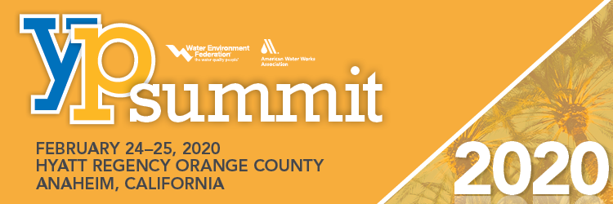
ATTENDANCE JUSTIFICATION
WEF/AWWA Young Professionals Summit l February 24-25, 2020

GENERAL TIPS
YP Summit attendees will learn about emerging issues in our industry and connect with a diverse group of YPs. The program is intended to challenge attendees to think critically about our industry (present and future) and to establish lasting connections with peers. Where else can you find so many water industry professionals facing the same issues as your organization? Are there solutions you’re not aware of? Here are several tips to guide you in your request for approval to attend YP Summit:

JUSTIFY THE EXPENSE
- Focus on the knowledge and information you will bring back to your organization and team as a return on the initial investment.
- Offer to deliver a short presentation and Q&A session to the other young professionals and their supervisors regarding your YP Summit experience and all that you have learned.
- Remind your supervisor that the YP Summit is a minimum of one day, so it is the most effective in terms of time and cost for the opportunity to brainstorm ideas and challenges facing the industry and how you can contribute by being a more sound technical, well rounded leader in your field.
- Be ready with a plan that shows who will help cover your workload while attending the YP Summit.
- Register early and reserve your hotel accommodations to receive the best rates and reduce the burden of cost on whomever may be sponsoring your travel.
- The YP Summit precedes the AWWA/WEF Utility Management Conference; as a young professional, you can register for the Utility Management Conference at a lower rate if you attend the YP Summit the day prior. The Utility Management Conference is attended by the utility managers from all over North America. The value of attending the sessions at the Utility Management Conference and networking with the attendants ranging for Utility managers for large cities, vendors, manufacturers, to consultants.

THE DETAILS
- Session Content:
  - Identify specific sessions that are relevant to your organizations work, or a project you are going to be working on in the future, or maybe even a topic that you are looking to explore as a part of your career path.
- Building Your Network:
  - There are young professionals in varied jobs that all contribute to the water industry and attend the YP Summit to grow their network. These can vary from vendors, municipal employees, and engineering consultants, to finance consultants, research agency, and permitting agency representatives.
  - This is an international event; there will be opportunities to network with other young professionals from all over the world, each with their own unique challenges.
  - Ensure that you will utilize your time to build this network with people who are potential clients, sub-contractors, and consultants to your future projects.
- Best Practices:
  - Highlight all the pertinent sessions that your team/organization could benefit from through your attendance.
  - Emphasize relevant sessions and workshops designed to teach specific technical or soft skills that will assist you in being a better team player and future leader.
- Utility Management Conference (UMC):
  - Research the benefits of attending this conference and emphasize the significant savings your organization will receive if you were to attend both YP Summit and UMC. Be sure to add them to the Benefits Worksheet and the letter to your supervisor.

Expenses Worksheet

Use the worksheet below to develop a cost estimate for attending the YP Summit. Refer to the registration and hotel information online.

Expense | Guideline |  | Cost
Summit Registration |  |  | $
Sunday Workshop | Optional |  | $
Lodging | See program guide for details |  | $
Mileage Reimbursement | Driving to summit or to the airport for your flight? Use an online mapping tool to calculate distances Is carpooling an option? |  | $
Flight | Try an online travel service to get a quick estimate |  | $
Transportation  (Airport to Hotel) | Taxi, rental car, Uber, etc. |  | $
Transportation  (Hotel to Airport) | Taxi, rental car, Uber, etc. |  | $
Parking Reimbursement | Airport parking for flight departure, or at hotel where summit is located. |  | $
Food Per Diem | Check on your organization’s policies.  Summit Registration includes Reception on Monday evening and luncheon Tuesday. |  | $
Total Expenses: |  | $

Benefits Worksheet
Powerful networking opportunities:  People that can save us money | UTILITY CONTACTS: I will find other utilities facing the same problems we face and will develop contacts who can share their knowledge of cost-effective solutions, so that I can learn from their mistakes and benefit from their successes.
 | VENDOR CONTACTS: I will meet vendors who know our processes and how they can be cost-effectively improved, including new technologies that can save us money in the long term.
 | SUPPORT CONTACTS: Government officials and engineers that know which technologies qualify for grant funding and how to obtain it.
 | REGULATORY CONTACTS: Agency reps that can help us clarify and understand our regulatory requirements so that we remain current on compliance issues.
Find solutions to our current problems (regulatory issues, equipment issues, management issues, customer service issues, process issues, etc.) | Issue 1:
 | Issue 2:
 | Issue 3:
 | Issue 4:
Find ways to do more with what we already have | I will meet vendors and operators that know our processes well and can give us insights into how we can deliver better performance, using equipment we currently use, but at a lower cost.
Find new technologies we should be studying now | I will see where the industry is heading, and which innovations are making it much more cost-effective to operate our processes.
Cross-training - Provide opportunities for others to learn my job and take on more responsibility | I plan to have________________cover my duties
 | while I am away. I will have this person ready to assume these duties before my departure, will meet with them for a debrief upon my return and will provide counselling/feedback/coaching for this person with written reports for supervisor's use and for their personnel file.
Staff presentations to "Share the Information" gained from the YP Summit | SUPERVISOR'S REPORT: I will prepare and submit a written report to my manager of my findings and of the short term and long-term action items that result from what I learn at YP SUMMIT.
 | STAFF BRIEFINGS: I will prepare and deliver a staff briefing of my findings so that others may benefit from what I learn at YP SUMMIT.
 | TRAINING ASSISTANCE: I will help others learn how to effectively attend a major summit like YP SUMMIT and deliver the maximum benefit to the Utility upon their return.

Sample Letter

After you have identified the specific advantages of attending the YP Summit, provide both the expenses and benefits for your manager to realize and approve the value of your proposition. Below is a sample letter that you can use as a template for your proposition.
< Date >
Dear < supervisor’s name >,
I would like to attend the WEF/AWWA Young Professionals Summit being held February 24-25, 2020 in Anaheim, CA. The conference will enable me to attend technical as well as professional development sessions that are directly applicable to my work and will allow me to network with a variety of water industry experts and colleagues from around the United States and Canada. Many of the presentations are tailored to the < your specific profession > water professional and give information on how to < list benefits to your responsibilities >. I am seeking approval for the registration fee, travel expenses to the conference, and lodging expenses during the conference. A detailed cost breakdown is included below.
After reviewing the YP Summit program, I have identified various methods that will allow me to gain knowledge and understanding on how we can improve my skill set. The presentations are all facilitated by industry experts who have faced similar challenges. I chose this program because the presentations <and workshop(s)> are directly related to <an issue> we are dealing with currently. Getting the information in a presentation format will greatly reduce the research time and costs that < your organization’s name > would normally incur in gaining insight into these topics.
< You will need to insert the session titles and descriptions which most apply to your responsibilities. >
The YP Summit registration fee is <$xxxx>.
< You will need to insert your travel cost numbers in here >
Here is the breakdown of conference costs:
Roundtrip Airfare: <$xxxx>
Transportation: <$xxxx>
Hotel: <$xxxx>
Meals: <$xxxx>
Registration Fee: <$xxxx>
The total costs associated with attending this conference are <$xxxx>.
The opportunity for me to develop better contacts and gain knowledge in specific areas of the water industry makes my attendance at the YP Summit a wise investment, which will yield rich dividends for < name of your organization>.
Sincerely,
< your name here >

Water Amplified: The Communication Revolution
This year's Summit brings an exciting new program filled with industry leaders, working in an unprecedented collaboration, who are redefining the industry and addressing the critical issue of communication in the water sector.
Participants will build effective communication skills through a cohesive full-day series of workshops.

Erin "Pink" Mosley & Tom Kunetz
Erin Mosley and Tom Kunetz design and conduct interactive workshops and engaging lectures on a variety of personal and professional development topics, including creating an innovation culture, career road mapping, and connecting with personal motivation and purpose.
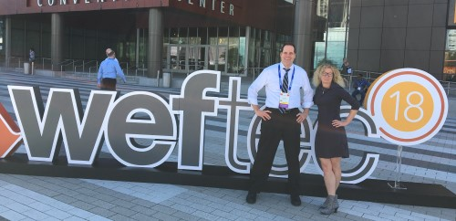

Their workshops blend Tom’s improv and discovery-by-doing expertise with Erin’s approaches in personal and executive coaching. Together they open new ways for participants to awaken personal creativity, inspire innovative solutions, and build successful teams.

Rogue Water
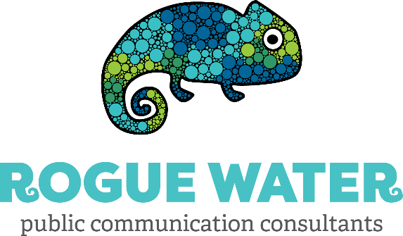
Ready to get amped about storytelling and communication, but not sure how it translates to your everyday? Rogue Water will demonstrate just that by partnering with Steven Drangsholt, an engineer with Brown and Caldwell out of Boise, ID. Rogue will be walking Steven through their story model with a real-life example of a story in action.
Stephanie Zavala  Co-Founder and CEO of Rogue Water  Arianne Shipley  Co-Founder and COO of Rogue Water  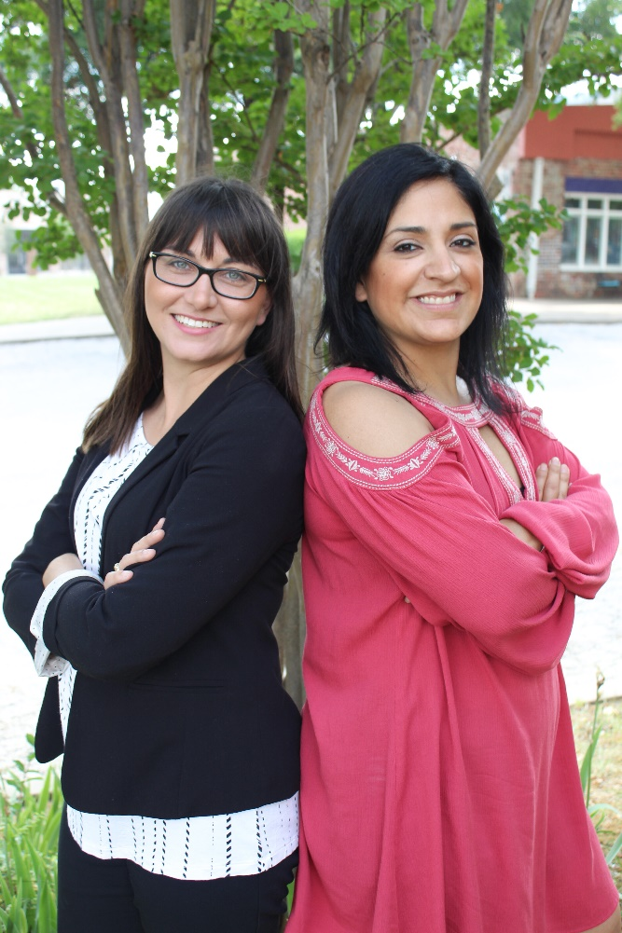 | Before founding Rogue Water, Stephanie and Arianne worked for municipal water utilities for ten years in education and communication, where they garnered awards from EPA, AWWA, Texas Water Development Board, Texas Association of Municipal Information Officers, 3CMA, and more. In 2019, Rogue Water earned a Worthy award and an Excellence in Marketing Award from Zweig.  Better known as the H2duO, they also co-founded the Rogue Water Lab, a non-profit venture cultivating the next-gen of innovators in water communication and education. The Lab is home to the Catalyst Mastermind Summit and the Water in Real Life podcast, both dedicated to communication in the water sector. The Lab serves as a Ted-Esque hub of resources designed to empower the storytellers of the water industry.

Dianna Crilley
Deputy Director, Office of Planning and Programming
U.S. Geological Survey
Water Resources Mission Area
Dianna Crilley will take her over 20 years of data management skills to teach participants how to use visualization tools to communicate data effectively.
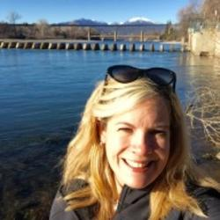 | Dianna M Crilley is the Deputy Director of the Office of Planning and Programming for the USGS. This office is responsible for managing all appropriated funding ($215M) for USGS water activities, top include developing and submitting the congressional Green Book on annual science priorities, as well as directing budget programming to support congressional, Bureau, and Presidential commitments and mission priorities.

In this role, Dianna also participates in a number of collaborative and National stakeholder engagement efforts, such as the Internet of Water, ACWI, and forums on water availability (quantity, quality, and use).

